Properties of a Wave Lab Name:
- Go to the address http://phet.colorado.edu and click on the orange play with sims button.
- On the left side, under simulation click on the Chemistry link.
- On the Chemistry simulations page, scroll to the bottom of the page and open the wave on a string simulation. Click the run now button to start the simulation.
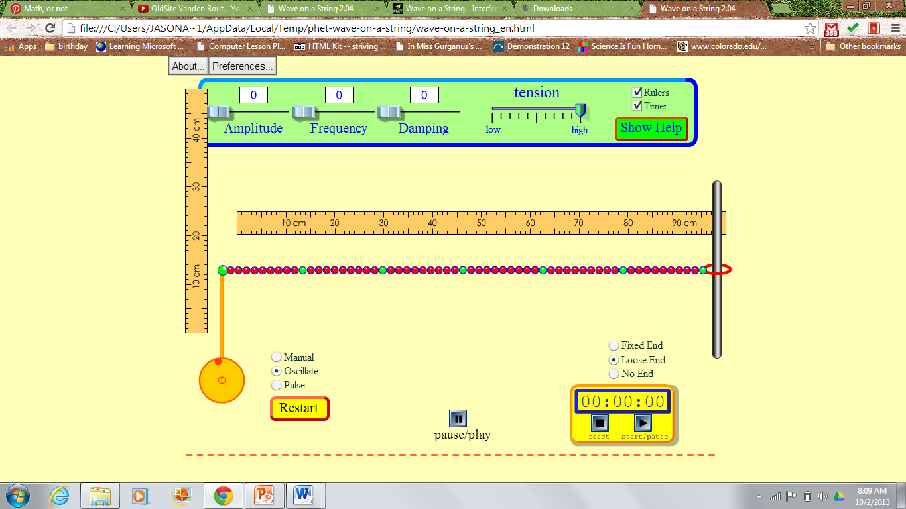
- Adjust the simulation to have the following settings (see pic above):
  - Set to oscillate
  - Set to no end
  - Set amplitude, frequency and damping to 0
  - Set tension to high
  - Check the rulers and timer boxes

- Record your observations of the string with the initial settings.

- Set the both the frequency and the amplitude to 35. What happens to the string?

- What is an oscillation or disturbance that travels through space called?

- Based on your observation of the wave define the following properties of a wave:

  - Peak

  - Wavelength

- Set the frequency to 50 and adjust the amplitude to several different settings. What happens to the string as you adjust the amplitude? Record your observations.

- Based on your observations, define the amplitude of a wave.

- Adjust the frequency button to several different settings. What happens to the string as you change the frequency? Record your observations.

- Based on you observations, define the frequency of a wave.

- You will now explore the relationship between frequency and wavelength. Set the amplitude to 50 and calculate the frequency of the wave for 5 different settings of frequency. To calculate frequency use the timer and count the number of peaks that pass through a given point per second.

- Next, measure the wavelength for each of the frequencies you calculated in step 13. Measure wavelength using the movable ruler and the pause button. Report your measurements in nanometers.

- Record your values of frequency and wavelength in a data table and then create a graph plotting frequency vs. wavelength.

- What is the relationship between frequency and wavelength?

- Light can be described as a wave. How fast does light travel? Are speed of light and the frequency of light the same thing? Explain.

